**British Airways Review Analytics Project**

**Project by Arihant Bhuyan**

# **Overview**

This Tableau dashboard presents a comprehensive analysis of Customer Reviews for British Airways, spanning from March 2016 to October 2023. By analysing key service aspects such as overall rating, cabin service, entertainment, food, ground service, seat comfort, and value for money, this dashboard enables dynamic exploration of British Airways' service performance. Through its interactive filters, the dashboard helps uncover insights across traveller types, aircraft models, seat classes, and geographical regions, providing actionable data-driven recommendations & insights for understanding both global and service-specific performance, helping to identify improvement areas.

**Interact with the Dashboard:** [**View Live Dashboard**](https://public.tableau.com/app/profile/arihant.bhuyan/viz/BAReviewAnalyticsProject/Dashboard1)

# **Key Dashboard Components and Inputs**

## **1. Header Metrics (Key Performance Indicators)**

* Average Rating: Represents the overall score provided by passengers based on applied filters.
* Service Metrics: Includes ratings for Cabin Staff Service, Entertainment, Food, Ground Service, Seat Comfort, and Value for Money. These KPIs summarize passengers’ experiences across different touchpoints.

**Insights**: These metrics give a quick snapshot of British Airways' performance. A lower score in categories like Food or Entertainment might signal areas where service enhancements are needed to improve overall satisfaction.



## 2**. Graphical Visualisations and their True Potential**

* **Average Overall Rating by Month (Line Chart)**:
  + This graph can dynamically change based on the selected metric. For instance, it can show overall trends in **entertainment** or **food ratings**.
  + **Analyst Use**: With a date filter applied, users can track **performance trends** over time. If an airline rolls out a new menu or introduces a new entertainment system, this trend line can show the direct impact of that change.

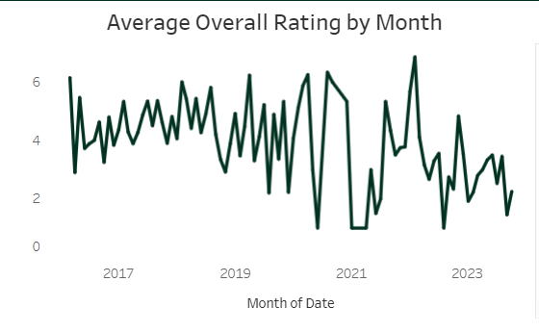

* **Geographical Performance: Average Rating by Country (Geographic Heatmap)**:
  + With **traveller type** and **seat class** filters applied, this map can show geographic disparities in satisfaction. For example, **premium class travellers in Europe** may have different expectations than those in **Asia**.
  + **Analyst Use**: This visual can help in operational decisions, such as optimizing resources for regions with lower satisfaction scores or exploring cultural nuances affecting service expectations.

* **Average Rating by Aircraft (Bar Chart)**:
  + The aircraft bar chart is linked to specific aircraft models (e.g., Boeing 747, A320). This allows the analyst to drill down into specific aircraft types to understand whether older or smaller planes receive lower ratings compared to newer, larger models.
  + **Analyst Use**: Airlines can decide on **fleet upgrades** or improvements based on feedback from specific aircraft, using this data to retire underperforming models or enhance services for highly reviewed ones.

* **Number of Reviews by Aircraft (Secondary Bar Chart)**:
  + This chart can be used to determine the volume of feedback for each aircraft type. Aircraft models that receive high volumes of low-rated feedback can be flagged for **further investigation** or **service improvements.**
  + **Analyst Use**: Prioritize aircraft models for deeper investigation based on **high feedback volume** but **low ratings**.

## **3. Dynamic Filters for Custom Analysis**

The dashboard allows users to filter the data based on several parameters, providing customized insights based on specific needs:

* **Pick a Metric**: Users can choose which metric to analyze in-depth (Overall Rating, Cabin Staff Service, Entertainment, etc.).
* **Date Filter (Month of Date)**: Allows for analysis of data trends over time, enabling users to compare ratings across different time periods, such as before or after significant events or service changes.
* **Traveller Type**: Segment the data based on customer demographics (Business, Family Leisure, Couple Leisure, etc.).
  + **Insights**: By analyzing specific traveller groups, British Airways can understand how different segments of customers perceive their services. For example, **Business Class** travellers might prioritize seat comfort and value for money, while **Family Leisure** travellers may focus more on cabin service and entertainment.
* **Seat Type**: Filters ratings by seat class (Business, Economy, First Class, Premium Economy).
  + **Deep Analysis:** This filter highlights how service ratings vary across different seat types, offering insights into whether premium customers receive better experiences compared to economy travellers.
* **Aircraft Group**: Analyze ratings by selecting specific aircraft models, providing insights into how certain fleets are performing relative to others.
* **Continent Filter**: Provides the ability to segment reviews by continent for a more region-specific analysis.

## **A screenshot of a computer Description automatically generated4. Filter-Driven Insights**

The power of this dashboard lies in how the filters allow you to ask more specific questions of the data:

* **Business Class on Newer Aircraft** (e.g., Boeing 787): Does premium seating on newer aircraft lead to higher ratings in comfort and food quality?
* **Family Leisure vs. Business Traveller Trends:** How do different traveller types perceive service elements like entertainment or ground service?
* **Seasonal Trends in Food Ratings**: How does food quality perception change during peak travel seasons (summer, holidays)?

# **Conclusion**

This British Airways Review Analytics Project dashboard is built with dynamic, interactive features that empower users to explore customer satisfaction data from multiple angles. With the ability to drill down into specific segments using filters like traveller type, seat class, aircraft model, and time period, users can uncover targeted insights. This interactive capability makes the dashboard suitable to make data-driven decisions to improve customer satisfaction.

# **How to Use**

* **Access the Interactive Dashboard**: View the live Tableau dashboard [here](https://public.tableau.com/app/profile/arihant.bhuyan/viz/BAReviewAnalyticsProject/Dashboard1).
* **Explore Metrics**: Use the filters to explore insights based on traveller type, seat class, aircraft type, or region.
* **Dive into Trends:** Analyse overall ratings and service-specific performance to identify areas for improvement or to highlight successful service models.